CS4321 Midterm Exam
Oct. 23, 2007 (75 points)

NAME: .

1 | 2 | 3 | 4 | 5 | 6 | 7 | 8 | 9 | 10 | Total
You may need the following equations.

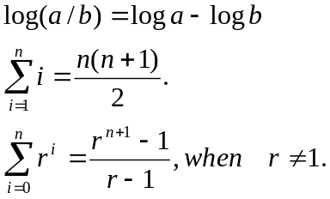

- (6 points) Prove that 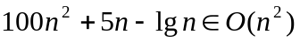using
  - (3 points) the definition of O.
  - (3 points) the limit rule.
- (10 points) True or false.

  - 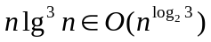 [ ]

  - 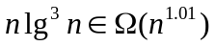 [ ]

  - 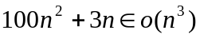 [ ]

  - 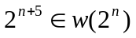 [ ]

  - The cost of heap sort is in 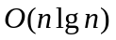 [ ]

  - With the assumption that the inputs are equally distributed, the average cost of insertion sort is [ ]

  - A sequence of n INCREMENT operations on an initially zero k-bit counter takes total worst-case time 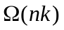 [ ]

  - A sequence of n INCREMENT operations on an initially zero k-bit counter takes total time 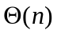 [ ]

  - If an algorithm takes best-case time Ω(f(n)), then the algorithm takes time Ω (f(n)). [ ]

  - If an algorithm takes worst case time Ө(f(n)), then the algorithm takes best case time O(f(n)). [ ]

- (5 points) Solving the following recurrence using the simplified version of Master theorem.

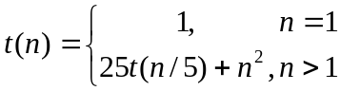

- (8 points) Analyze the cost of following algorithm. Show detail steps.

void DC(int n) // n >= 1
{
int i, j, k;

if (n < 4) return;

for (i = 1; i <= 10; i++)
DC(n/4);

for (i = 1; i <= n; i++)
for (j = 1; j <= i; j++)
for (k = 1; k <= 16; k++)
constant work;
}

- (8 points) Assuming that n is an exact power of 7, we are going to analyze the following algorithm.
  - Which instruction do you want to use as the barometer?
  - Develop an exact function for the number of times your barometer executes.
  - Express the cost of this algorithm using the big- notation.

int counter = 0;
void Foo (int n) { // n is an positive integer and exact power of 7.
{
int i, j;

for (i = 1; i <= n; i *= 7) {
for (j = 1; j <= 5*i; j++) {
counter++;
}
}
}

- (10 points) Find a good asymptotic upper bound for the following recurrence using the recursion tree method. Verify your upper bound using the substitution method.
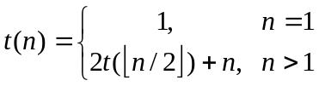
- (6 points) Show the binomial heap that results when the node with value 17 in the following binomial heap is deleted.

25
12
18
37
41
13
29
14
38
15
17
19
27

- (8 points) Design an efficient algorithm that updates the key of a heap node A[i] to k.
  - (4 points) Write your algorithm. You can call any algorithms discussed in class.
  - (2 points) What is the worst case cost of your algorithm? When does it happen?
  - (2 points) What is the best case cost of your algorithm? When does it happen?
- (6 points) A sequence of stack operations is performed on a stack whose size never exceeds k. The three stack operations are push, pop, and copy that are defined as following
- Push(S, x): pushes object x onto Stack S. Its cost is 1.
- Pop(S): pops the top of stack and returns the popped object. Its cost is 1.
- Copy(S): backs up the entire stack. Its cost is equal to the number of objects of the stack.
Assuming that Copy(S) is called after every k stack operations of push or pop, argue the following amortized cost using the accounting method.
- Push: 2
- Pop: 2
- Copy: 0
- (8 points) Prove that the following routine finds the second largest value in an array of size greater than or equal to 2 using the loop invariant below.
S_{i}: largest is the largest value and second is the second largest value in A[0..i].

int no2(int A[], int n) // n is the size of A[0..n-1]; n>=2
{
int i, largest, second;

if (A[0] > A[1]) {
largest = A[0];
second = A[1];
} else {
largest = A[1];
second = A[0];
}

for (i = 2; i < n; i++) {
if (A[i] > largest) {
second = largest;
largest = A[i];
} else if (A[i] > second)
second = A[i];
}

return second;
}

